Association of Greek Judges and Prosecutors
Court of First Instance of Athens
10171 Athens Greece
email: endikeis@otenet.gr
Tel.00302108827380- Fax 00302108841529

Athens, 10/1/2020

Since 2015 the government in Poland proposed several legal provisions in the sole aim to exercise a political control over justice. In 2019, the new disciplinary regime undermines the judicial independence of Polish judges and does not ensure the necessary guarantees to protect judges from political control. Specifically, the draft law on the disciplinary liability of judges in Poland establishes that a judge “shall be disciplinary responsible for official (disciplinary) offenses, in particular for: 1) an obvious and blatant insult to legal provisions, including refusal to apply a provision of an act, if its non-compliance with the Constitution or an international agreement has not been found by the Constitutional Tribunal”.
This provision, as it stands, allows ordinary court judges to be subjected to disciplinary investigations, procedures and sanctions on the basis of the content of their judicial decisions. Moreover, the new disciplinary regime does not guarantee the independence and impartiality of the Disciplinary Chamber of the Supreme Court, which is composed solely of judges selected by the National Council for the Judiciary, which is itself politically appointed by the Polish Parliament. Furthermore, the new disciplinary regime does not ensure that a court “established by law” will decide in the first instance on disciplinary proceedings against ordinary court judges. Instead, it empowers the President of the Disciplinary Chamber to determine, on an ad-hoc basis and with an almost unfettered discretion, the disciplinary court of first instance to hear a given case brought against an ordinary court judge.
Therefore, the Greek Association of Judges and Prosecutors fully supports the Polish colleagues in their fight against any political control and any attempt to undermine their independence.
The Greek Association of Judges and Prosecutors condemns any attempt to transform the judiciary in Poland, as well as in any other country, to an instrument of governmental politics, since a free and independent justice is fundamental to the effectiveness of a Democratic State.
As a sign of solidarity to the Polish Judges, the Greek Association of Judges and Prosecutors will participate to the Silent March, organized by the Polish Judges Association “Justitia”, which will be held to Warsaw on the January 11th, 2020, represented by Georgios Kasimis, President within the Court of First Instance in Athens.

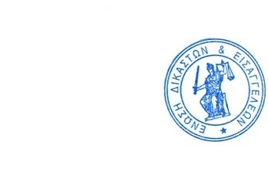
Yours sincerely,

Dr. Christoforos Sevastidis,
President of the Association
Of Greek Judges and Prosecutors

